LAB 1
Network & Service Reconnaissance with Metasploitable 2
Nmap fundamentals, service enumeration, NSE and WhatWeb fingerprinting
Field | Value
Name | Ayodele Banjo
Student ID | C11/26/FCDF/17169
Environment | Authorized laboratory environment — Oracle VirtualBox

1. Summary
For this lab I ran network and service reconnaissance against the authorized Metasploitable 2 VM at 192.168.56.101, using Kali Linux at 192.168.56.102 as my attack box. I worked through host discovery, TCP and UDP scanning, service/version detection, OS fingerprinting, safe NSE script enumeration, a manual HTTP check with curl, and WhatWeb fingerprinting. By the end I'd found 30 open TCP ports, a handful of open and open|filtered UDP ports, an OS estimate of Linux 2.6.x, and a deliberately old, broad set of legacy services. No exploitation was attempted anywhere in this lab.

2. Authorization and Scope
Everything documented here was run only against the instructor-authorized Metasploitable 2 VM, inside an isolated Oracle VirtualBox lab. Public systems, random IP addresses, and production infrastructure were never in scope.
Field | Recorded value
Assessment platform | Kali Linux virtual machine
Virtualization software | Oracle VirtualBox
Kali interface | eth0
Kali IPv4 address | 192.168.56.102/24
Target | Metasploitable 2
Target IPv4 address | 192.168.56.101/24
Network range | 192.168.56.0/24
Nmap version | 7.99
Authorized activity | Network and service reconnaissance only

3. Interpreting Nmap Output
Field/State | Meaning
PORT | The port number plus protocol, like 22/tcp.
open | Something's actually listening and accepting traffic on that port.
closed | The host answered, but nothing's listening there.
filtered | Some kind of filtering is stopping Nmap from telling either way.
open|filtered | Same idea, but for UDP — no clear reply either way, so Nmap can't say for sure if it's open or just being filtered.
SERVICE | Nmap's best guess at what's running on the port.
VERSION | The actual product and version, once -sV manages to pin it down.

4. Lab Preparation and Host Discovery

Step 1: Identify the Kali Linux address
ip addr — the active interface was eth0, IPv4 192.168.56.102/24. Ignored the loopback address, as expected.

Step 2: Identify the Metasploitable 2 address
ifconfig, run inside Metasploitable 2 itself, showed eth0 at 192.168.56.101, netmask 255.255.255.0.
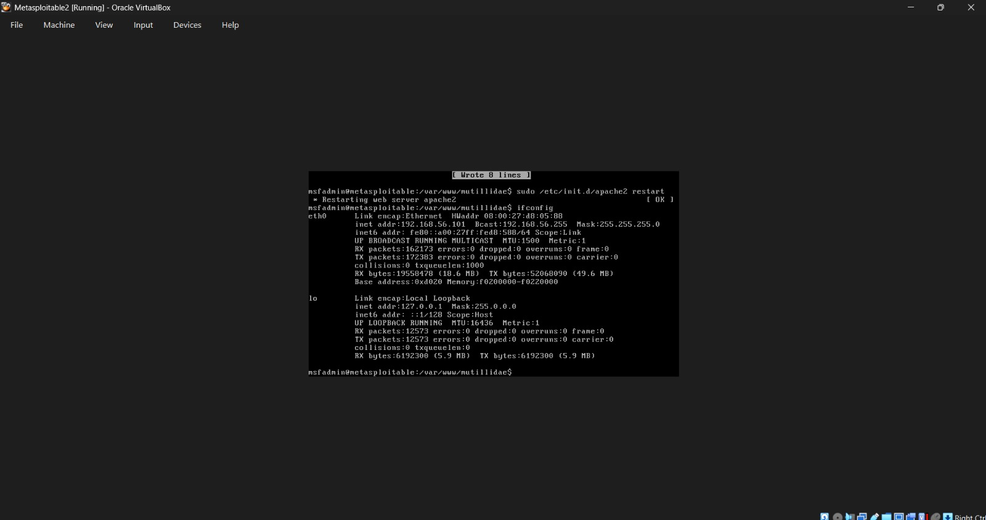
Figure 1. Metasploitable 2 interface configuration showing target address 192.168.56.101.
This is the target's own ifconfig output, confirming the address I'd be scanning.

Step 3: Confirm connectivity
ping -c 4 192.168.56.101 came back clean — all four echoes replied, 0% loss, so the two VMs can definitely talk to each other.

Step 4: Discover live hosts
nmap -sn 192.168.56.0/24 turned up four live hosts on the lab subnet. Matched the target to 192.168.56.101 using the address plus its VirtualBox MAC info.
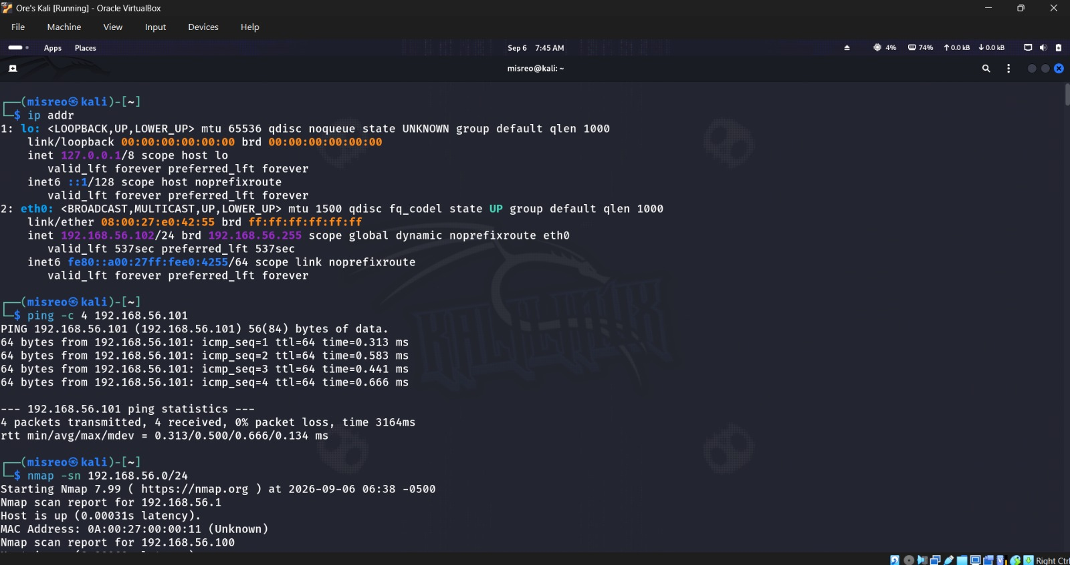
Figure 2. Kali address, successful four-packet ping, and start of host discovery.
Kali's own address, the ping test succeeding, and the host-discovery scan just getting underway.
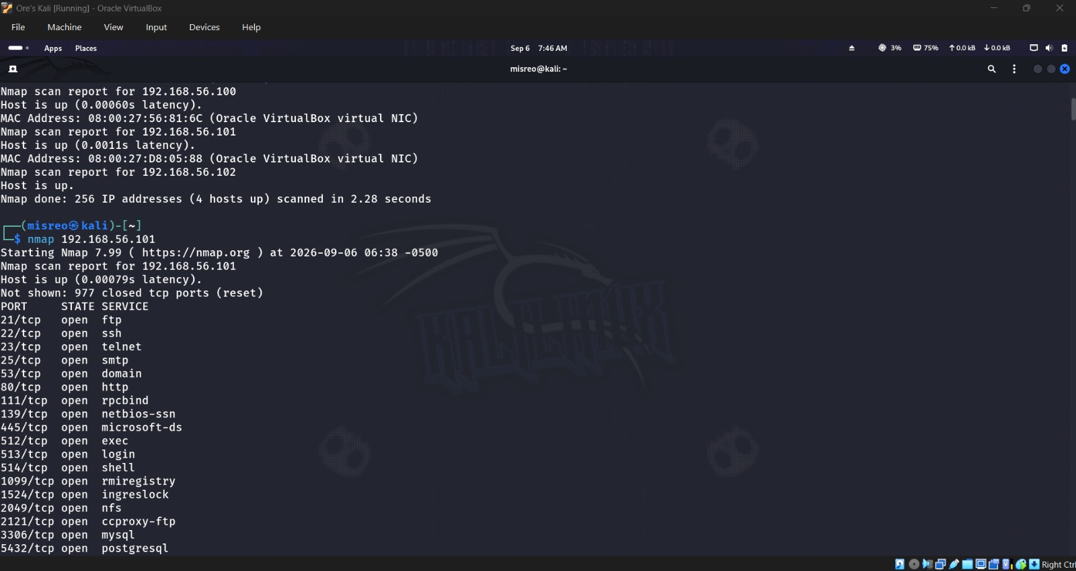
Figure 3. Host-discovery completion and beginning of the default target scan.
Host discovery wrapping up, right before the default scan against the target kicks off.

5. Core Nmap Scans

Step 5: Default TCP scan
nmap 192.168.56.101 checked Nmap's usual common-port set and found 23 open ports — a real mix of FTP, SSH, Telnet, SMTP, DNS, HTTP, RPC, SMB, remote shell services, a couple of databases, VNC, X11, IRC, AJP13, and a Tomcat HTTP port.
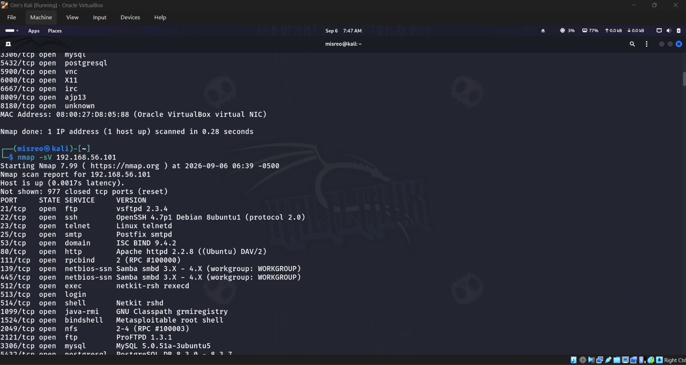
Figure 4. Remaining default-scan results and start of service/version detection.
The rest of the default scan's results, right as -sV starts running next.

Step 6: Service and version detection
nmap -sV pinned down actual products behind those ports — vsFTPd 2.3.4, OpenSSH 4.7p1, ISC BIND 9.4.2, Apache HTTP Server 2.2.8, MySQL 5.0.51a, PostgreSQL 8.3.x, UnrealIRCd, and the Tomcat/Coyote JSP engine 1.1, among others.
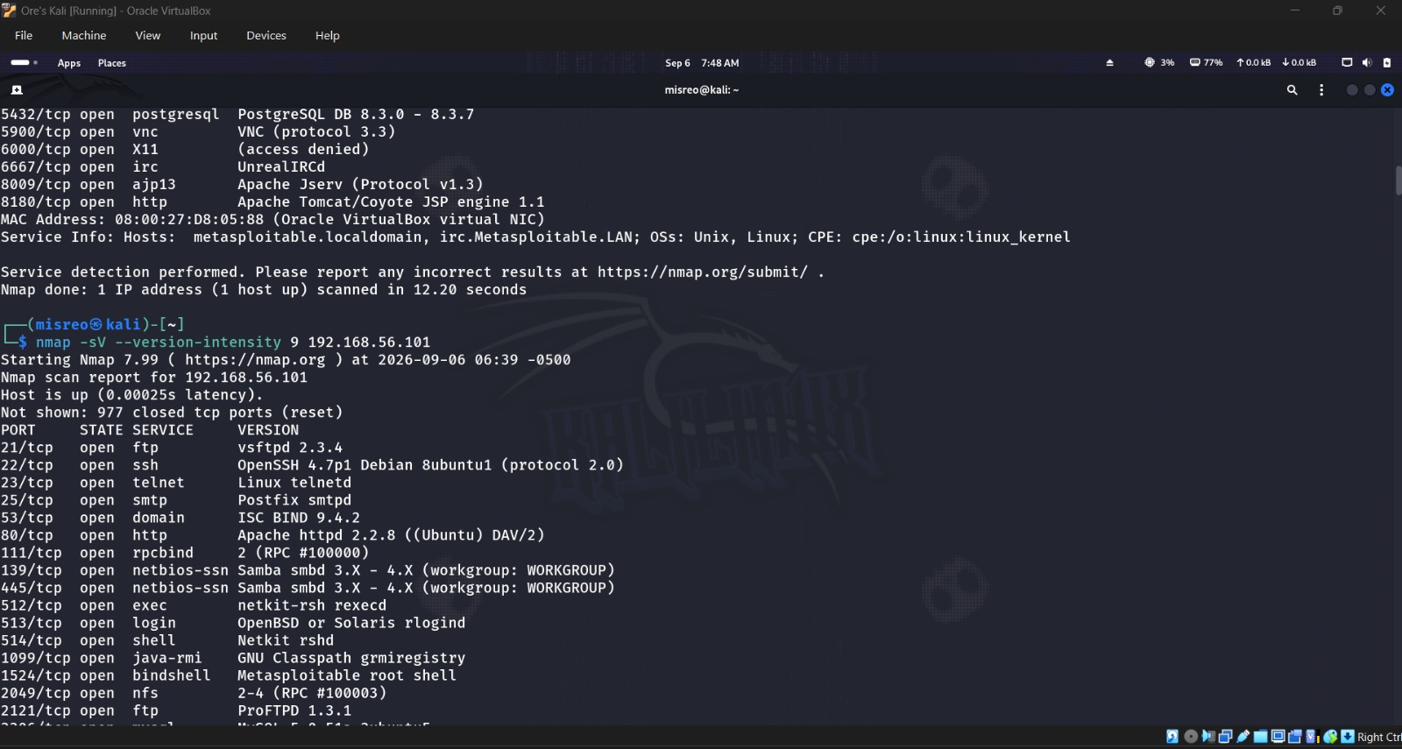
Figure 5. Service/version detection results and start of maximum-intensity probing.
Service/version results, with the version-intensity 9 run starting right after.

Step 7: Maximum version intensity
Bumping the version-probe intensity all the way to 9 didn't really change anything — same services came back, and it actually finished a touch faster (12.15s vs 12.20s for the normal -sV run), so no meaningful gain here.
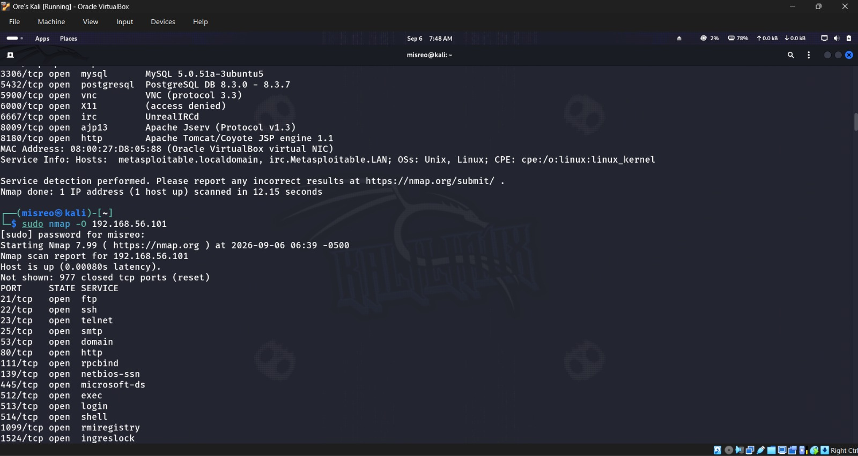
Figure 6. Completion of maximum-intensity version detection and start of OS detection.
Intensity-9 run wrapping up, OS detection about to begin.

Step 8: Operating-system detection
sudo nmap -O guessed a general-purpose Linux 2.6.x box (somewhere between 2.6.9 and 2.6.33), one hop away — worth remembering this is an estimate, not a confirmed fact.
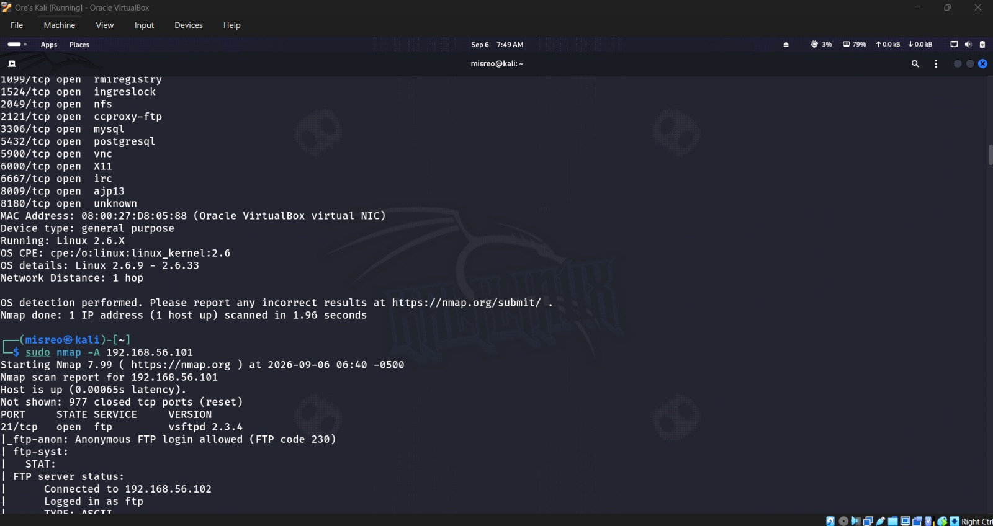
Figure 7. Linux 2.6.x operating-system estimate and start of the aggressive scan.
The OS estimate, right before the aggressive scan starts.

Step 9: Aggressive scan
sudo nmap -A pulled together version detection, OS detection, the default NSE scripts, and a traceroute in one go. Compared with the plain default scan, it added a lot — detailed versions, confirmation that anonymous FTP works, SSH host-key info, the HTTP title and server string, RPC program mappings, SMB host details, and a one-hop traceroute. Took 22.84 seconds total.
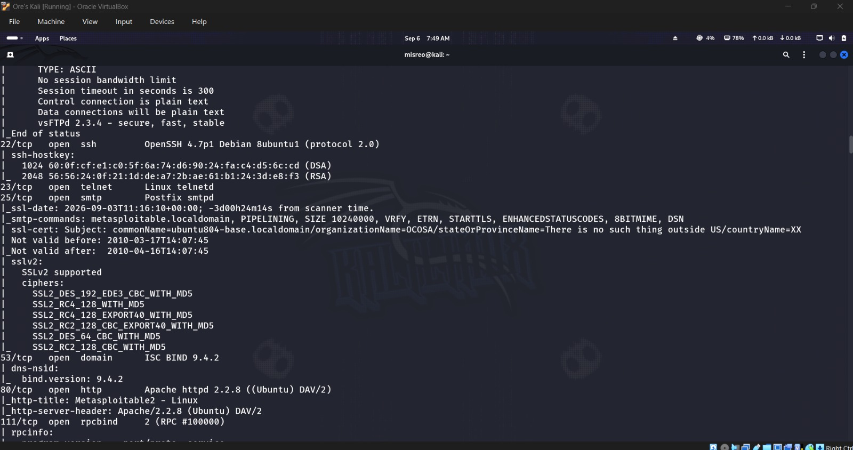
Figure 8. Aggressive-scan findings for FTP, SSH, SMTP, DNS, and HTTP.
The first batch of -A results, covering FTP through HTTP.
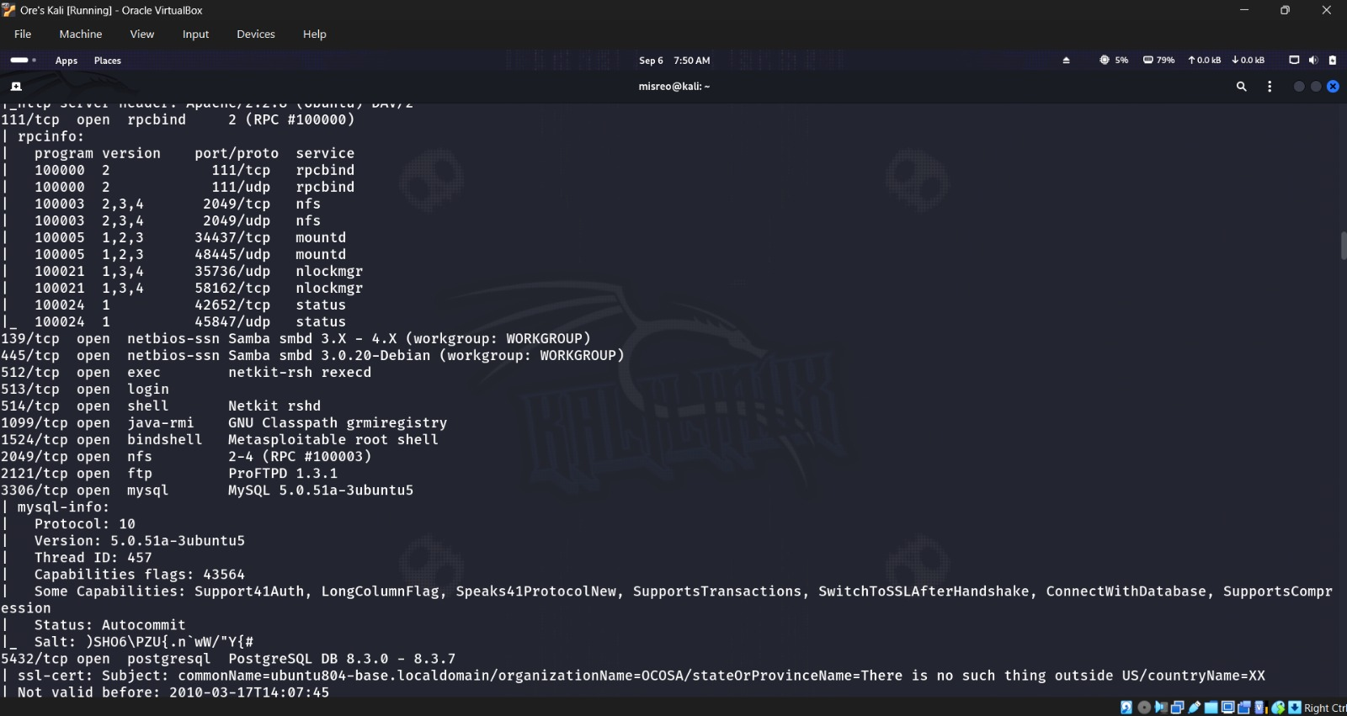
Figure 9. Aggressive-scan RPC, SMB, database, and other service details.
More -A output — RPC, SMB, and the database services.
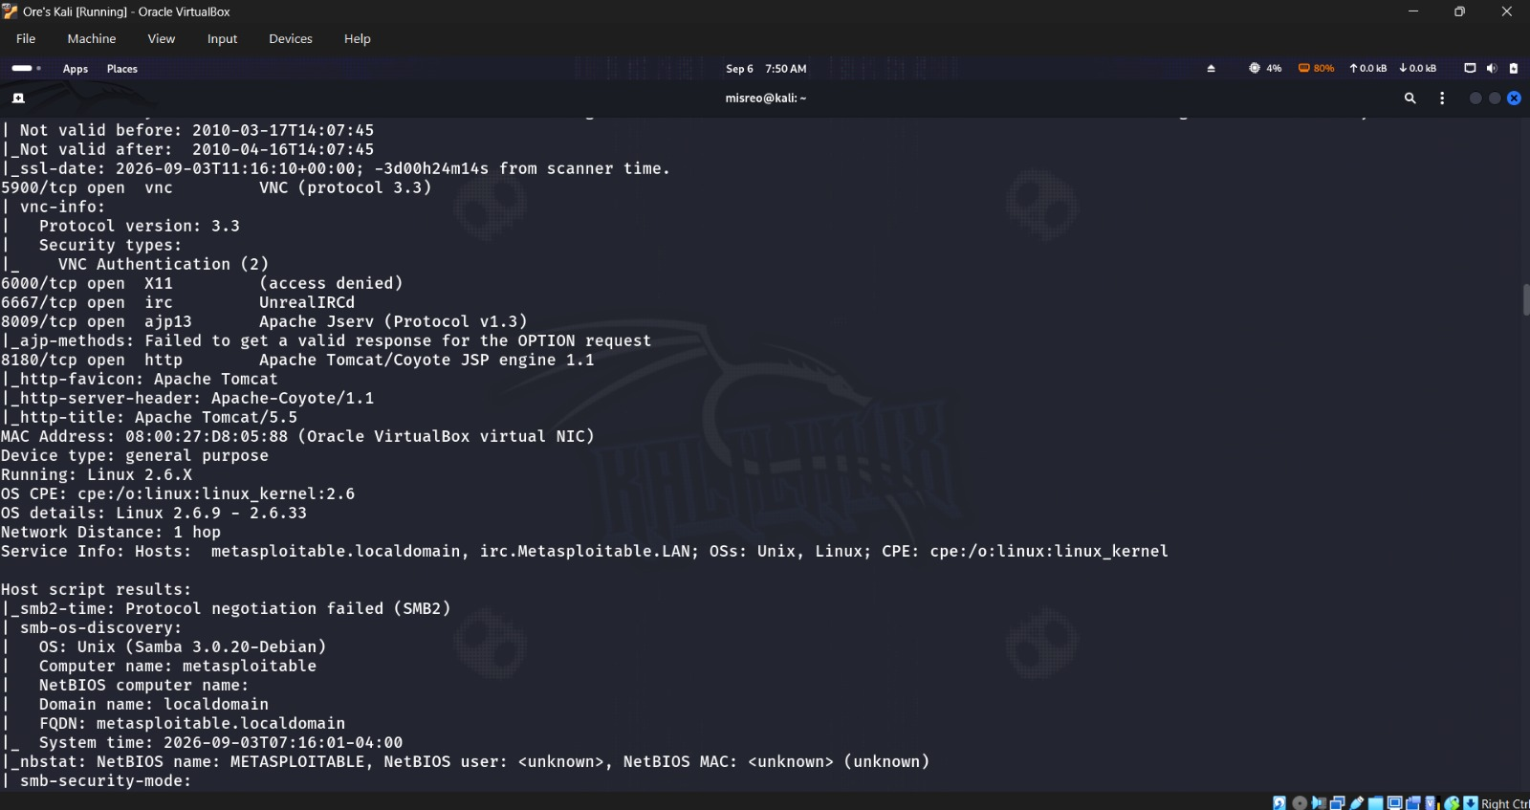
Figure 10. Aggressive-scan OS and SMB host-script findings.
The OS guess again here, alongside SMB host-script detail.
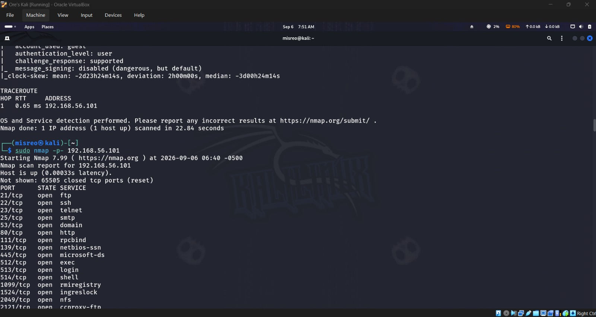
Figure 11. Aggressive-scan completion, traceroute, and start of the full TCP scan.
The -A scan finishing up with its traceroute, right before the full TCP scan begins.

Step 10: Full TCP port scan
sudo nmap -p- covers all 65,535 TCP ports and turned up 30 open ones this time — seven more than the default scan: 3632, 6697, 8787, 34437, 42652, 45372, and 58162. Finished in 5.87 seconds.
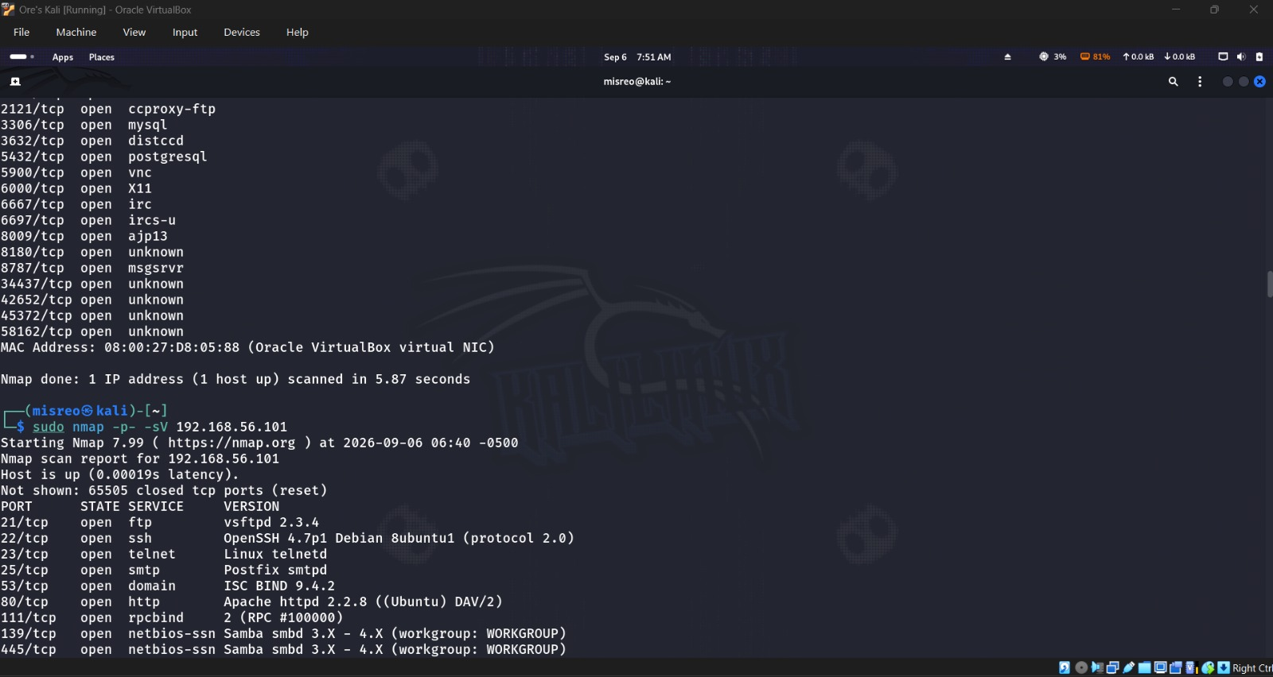
Figure 12. Completion of the full TCP scan and beginning of the full service/version scan.
The all-port scan wrapping up, with -p- -sV about to run next.

Step 11: Full TCP scan with versions
Combining -p- with -sV gave me the fullest picture — distccd, a second IRC listener, Ruby DRb RMI, mountd, status, the GNU Classpath RMI registry, and nlockmgr all showed up on top of what was already found. This one took a while: 134.66 seconds.
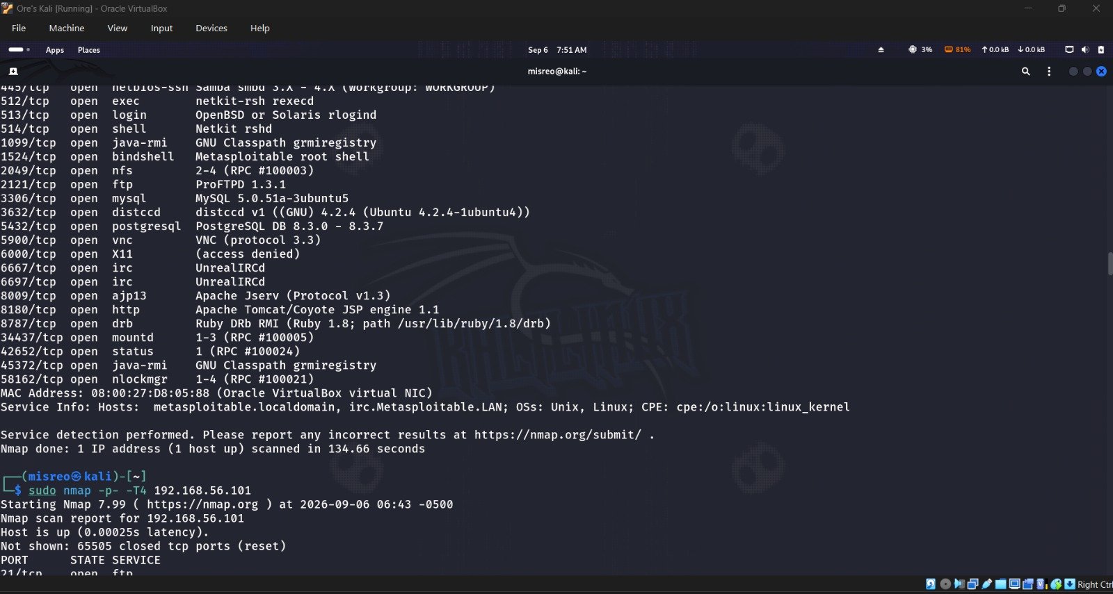
Figure 13. Full TCP service/version inventory and start of the T4 comparison scan.
The complete TCP service inventory, right before the T4 timing comparison starts.

Step 12: Timing-template comparison
Same 30 ports came back with -T4, but it actually took a bit longer this run — 8.10s versus 5.87s for the earlier full scan. Scan time isn't fixed; it moves around with system load and network timing, so T4 being 'faster' isn't guaranteed on every single run.
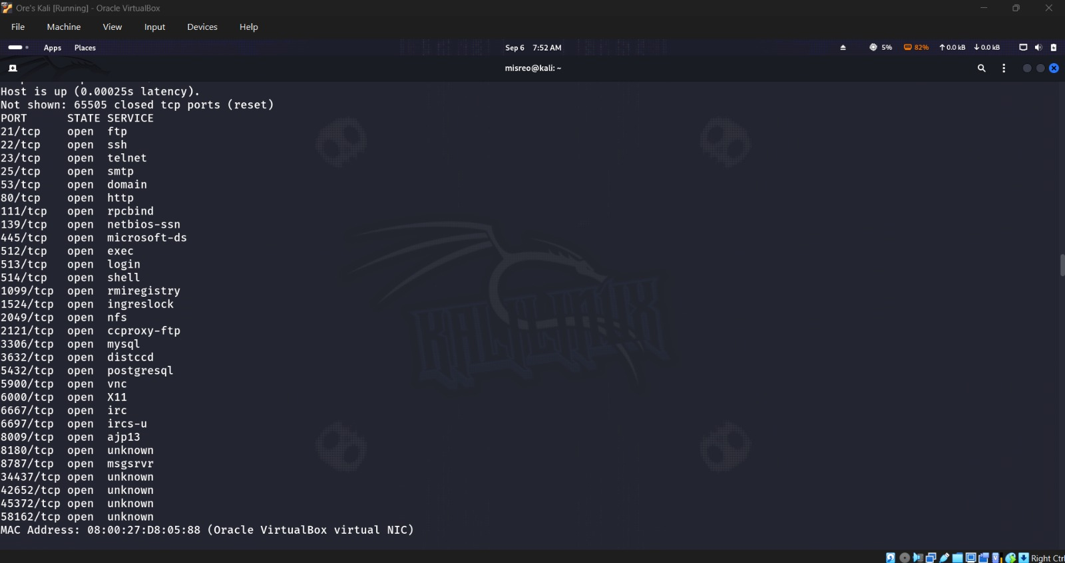
Figure 14. T4 full-port scan showing the same 30 open TCP ports.
The T4 run, landing on the same 30 ports as before.

Step 13: Selected-port scan
nmap -p 21,22,23,25,80,139,445 checked exactly those seven ports and all came back open — done in 0.33 seconds. This kind of focused scan is handy when you already know which services you care about and just want a quick confirmation.

Step 14: Continuous port range
nmap -p 1-1024 covers a continuous block instead of a hand-picked list, and returned whatever was open in that range — 0.31 seconds, so basically as fast as the selected-port scan.
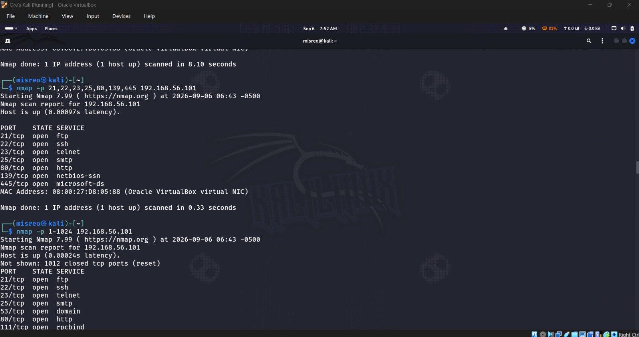
Figure 15. Selected-port results and start of the 1–1024 port-range scan.
Results from the selected-port scan, with the 1–1024 range scan starting right after.

Step 15: UDP scan
sudo nmap -sU found ports 53, 111, 137, and 2049 clearly open, with 68, 69, 138, and 903 coming back open|filtered. This one took forever — 1051.06 seconds, about 17 minutes 31 seconds — which is exactly why UDP scanning has a reputation for being slow. A couple of earlier attempts got interrupted and weren't counted as final results.
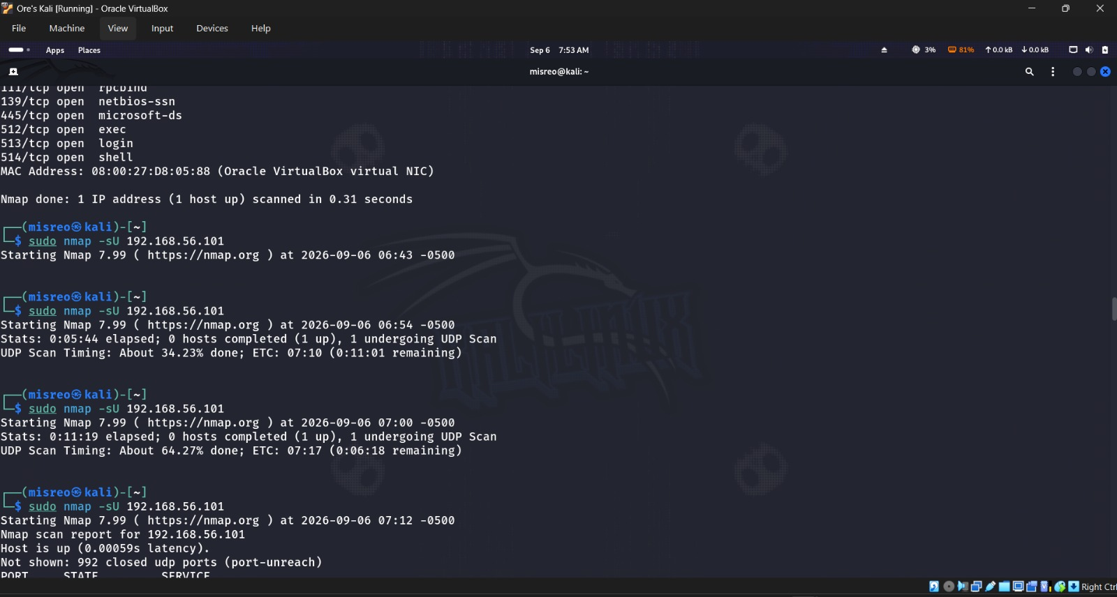
Figure 16. Port-range completion, interrupted UDP attempts, and start of the completed UDP scan.
The earlier interrupted UDP attempts, followed by the run that actually completed.

Step 16: Top 20 UDP ports with versions
Narrowing it down to the top 20 UDP ports with -sV finished in 111.45 seconds and actually identified things — ISC BIND 9.4.2 on 53/udp and NetBIOS name service on 137/udp — alongside a mix of closed and open|filtered results. The NetBIOS probe hinted at Windows, but everything else — the TCP fingerprints, OS detection — pointed clearly to Linux, so that one isolated signal didn't get much weight.
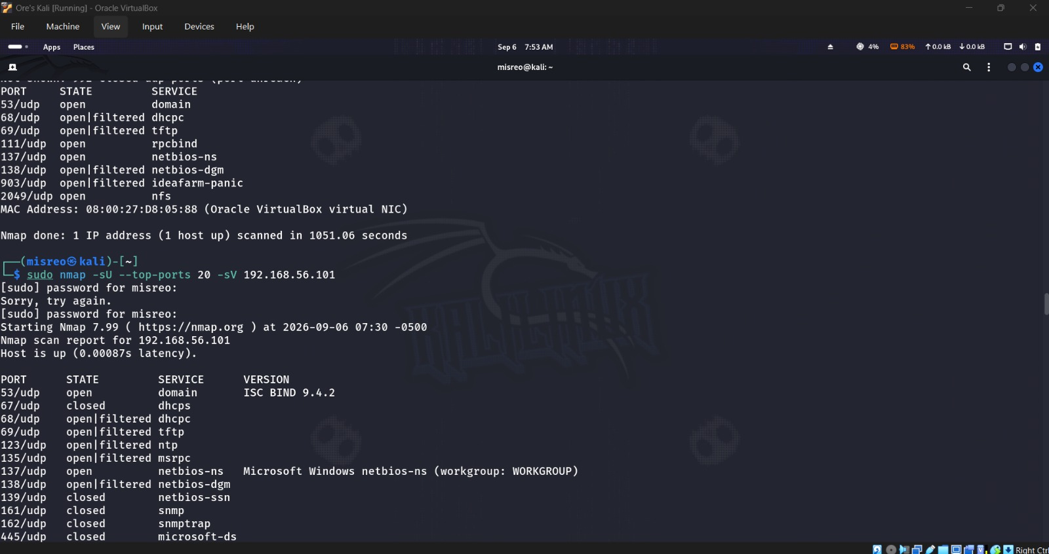
Figure 17. Completed UDP results and beginning of the top-20 UDP version scan.
The completed broad UDP scan, right before the more focused top-20 run starts.
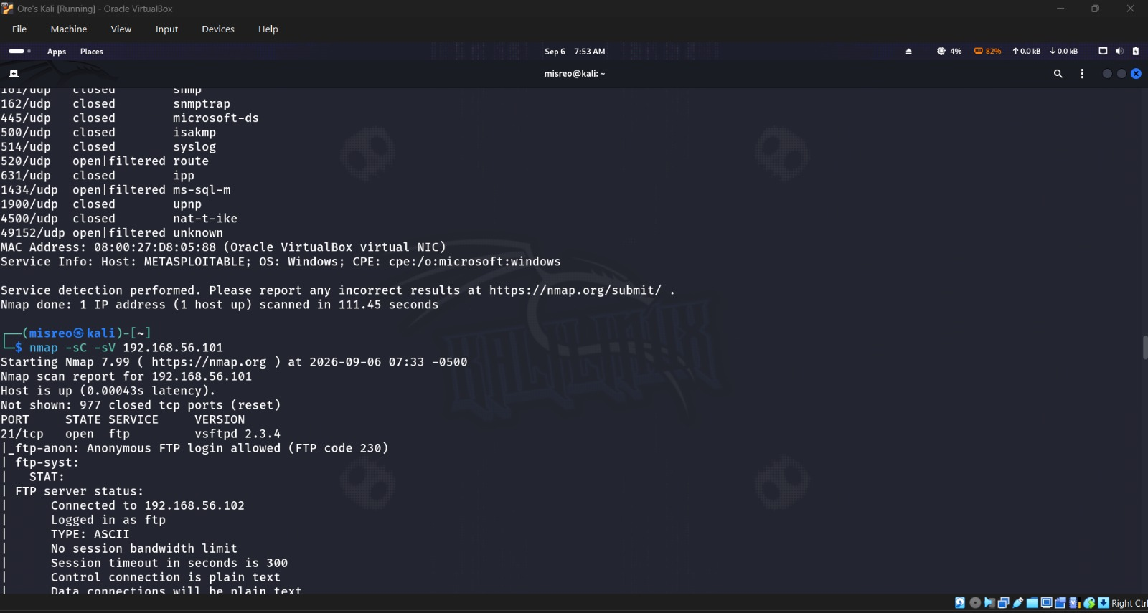
Figure 18. Top-20 UDP results and beginning of default NSE enumeration.
Top-20 UDP results, with NSE default-script enumeration about to begin.

6. Safe NSE Enumeration

Step 17: Default scripts with version detection
nmap -sC -sV brought back a lot of useful context — anonymous FTP login, SSH DSA and RSA host keys, SMTP command support, the HTTP title/server values, RPC mappings, SMB security settings and host identity, some database metadata, VNC protocol info, and Tomcat details.
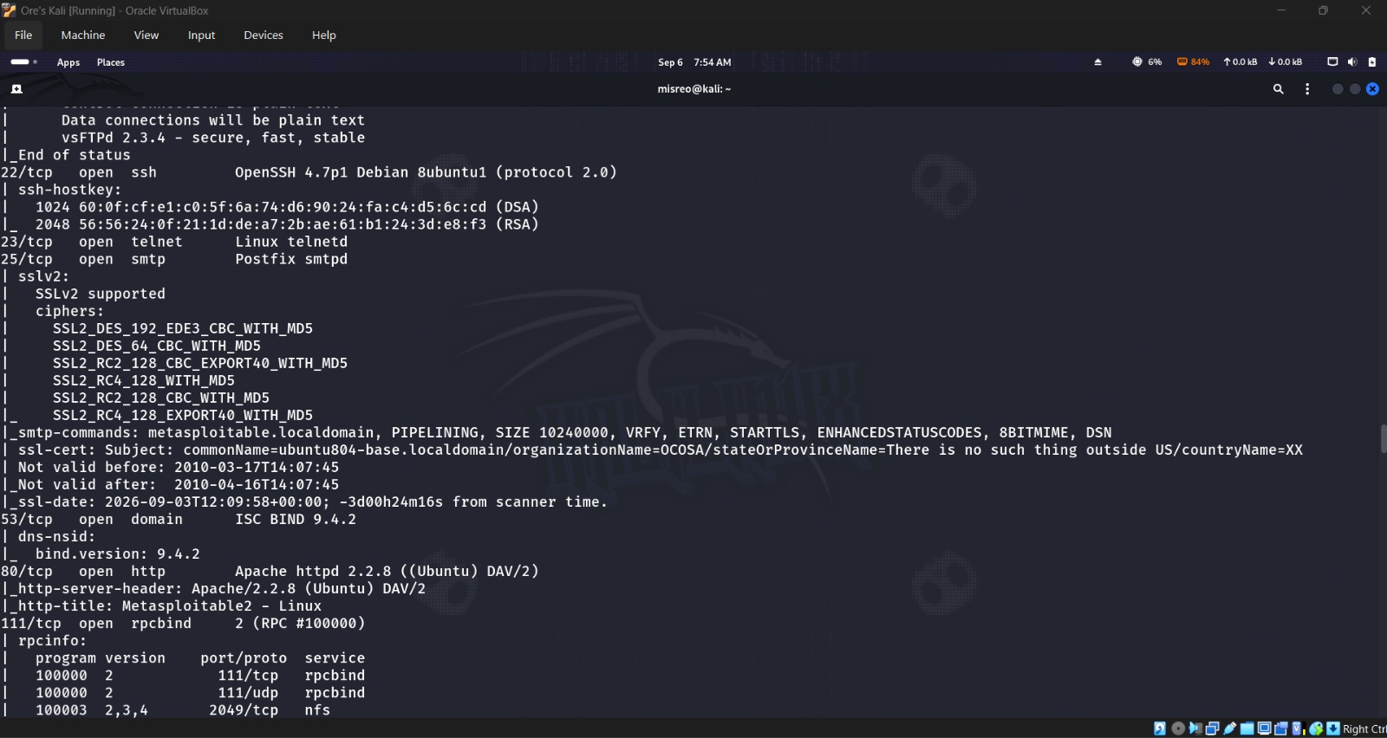
Figure 19. NSE results for FTP, SSH, SMTP, DNS, HTTP, and RPC.
NSE default-script output covering FTP through RPC.
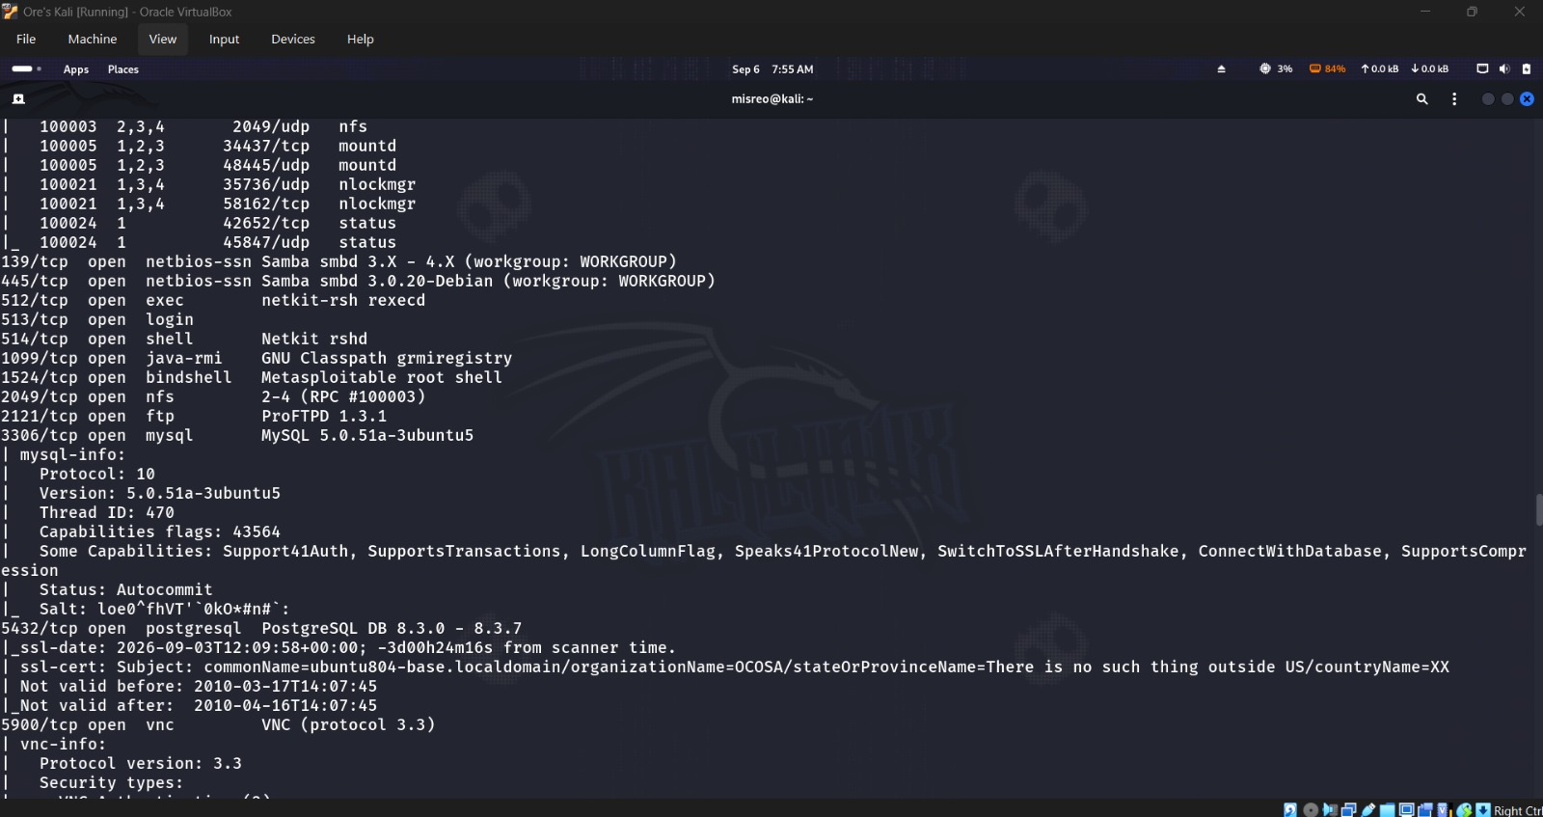
Figure 20. NSE database, certificate, and VNC results.
More NSE output — database metadata, certificate info, and VNC.
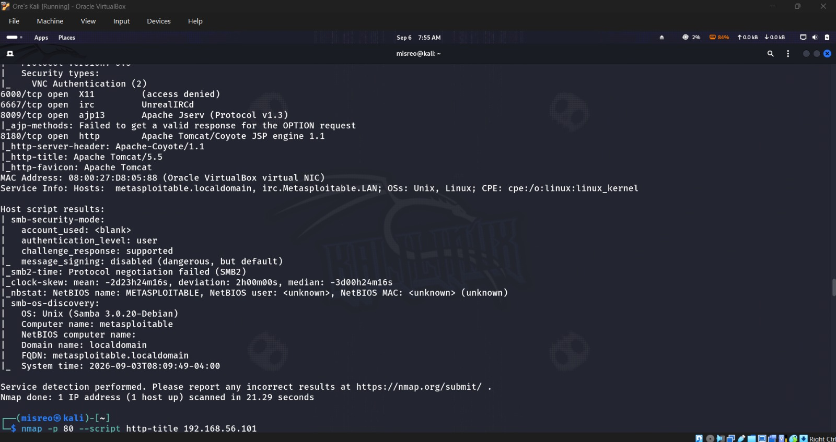
Figure 21. Completion of NSE results with SMB host information.
NSE wrapping up with SMB host identity details.

Step 18: HTTP title
The http-title script came back with the page title exactly as it is: “Metasploitable2 - Linux.”

Step 19: HTTP headers
http-headers showed Apache/2.2.8 (Ubuntu) DAV/2 as the server, PHP/5.2.4-2ubuntu5.10 via X-Powered-By, a connection: close header, and text/html content type.
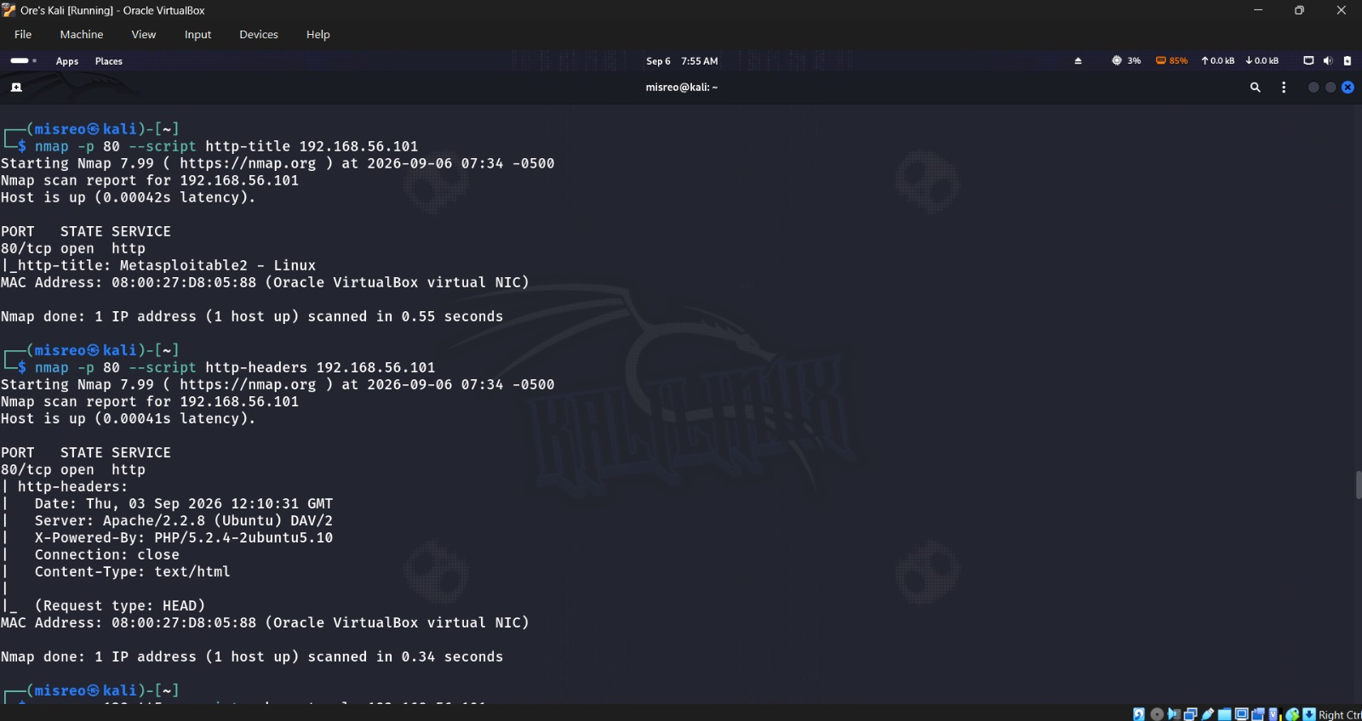
Figure 22. HTTP title and HTTP header script results.
Both the title and header script output, side by side.

Step 20: SMB protocols
smb-protocols confirmed the service still supports NT LM 0.12 — that's SMBv1 — which Nmap flags outright as a dangerous dialect, even though it's enabled by default here.

Step 21: SSH host keys
ssh-hostkey pulled both DSA and RSA host-key algorithms off the server. Only the algorithm names are recorded here, but the full fingerprints are sitting in the screenshot if needed.
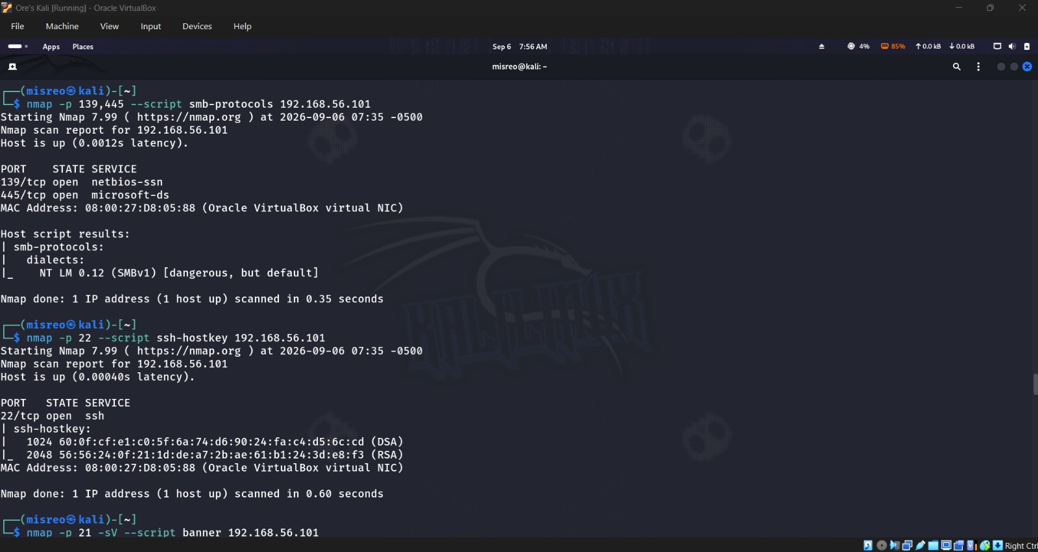
Figure 23. SMBv1 protocol support and SSH DSA/RSA host-key algorithms.
SMB protocol support and the SSH host-key results together.

Step 22: FTP banner
Running -sV alongside the banner script on FTP gave two things that agreed with each other — the VERSION column said vsFTPd 2.3.4, and the raw banner text read “220 (vsFTPd 2.3.4).”
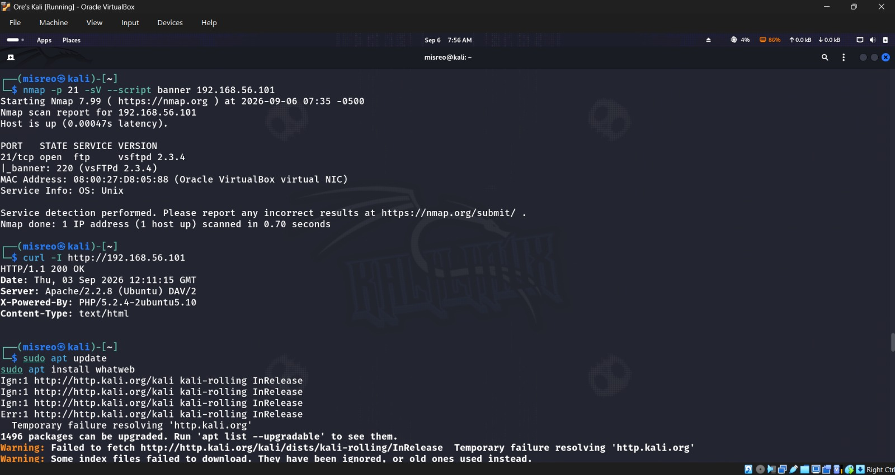
Figure 24. FTP banner, curl HTTP confirmation, and WhatWeb availability check.
The FTP banner result, leading into the curl and WhatWeb checks that follow.

7. Manual HTTP Confirmation

Step 23: Request HTTP headers with curl
curl -I http://192.168.56.101 came back HTTP/1.1 200 OK, with the same Apache/2.2.8 (Ubuntu) DAV/2, PHP/5.2.4-2ubuntu5.10, and text/html details Nmap had already shown — a good cross-check that both tools agree with each other.

8. WhatWeb Fingerprinting

Step 24: Basic fingerprint
Plain whatweb came back with a 200 OK, the “Metasploitable2 - Linux” title, Apache 2.2.8, Ubuntu Linux, WebDAV 2, PHP 5.2.4-2ubuntu5.10, and the target's IP address.

Step 25: Verbose fingerprint
-v broke that same result down plugin by plugin — Apache, HTTPServer, PHP, WebDAV, X-Powered-By — plus the complete set of HTTP response headers.
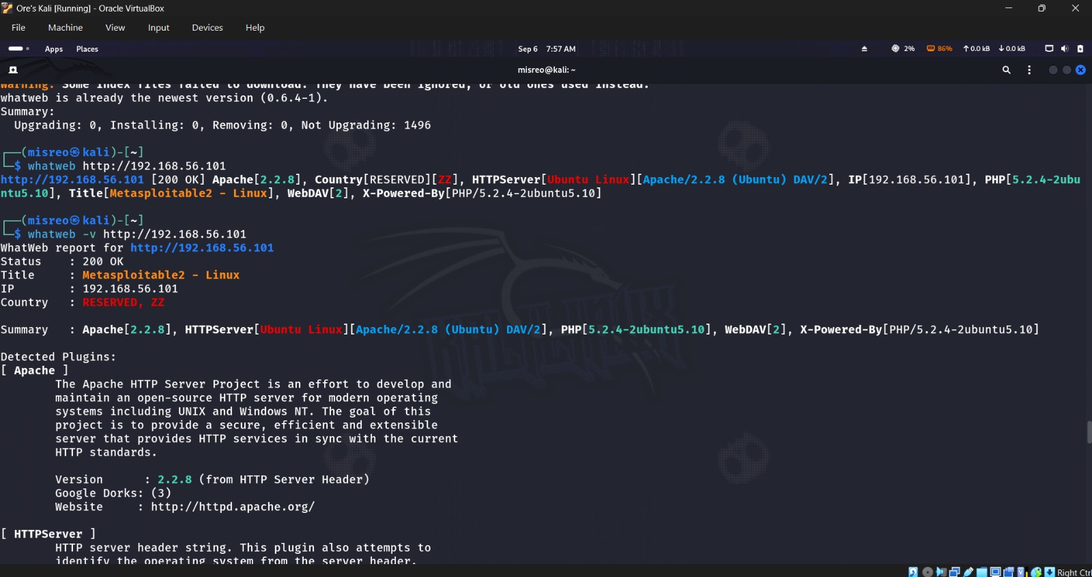
Figure 25. Basic WhatWeb fingerprint and beginning of verbose output.
The basic fingerprint result, with verbose mode starting right after.
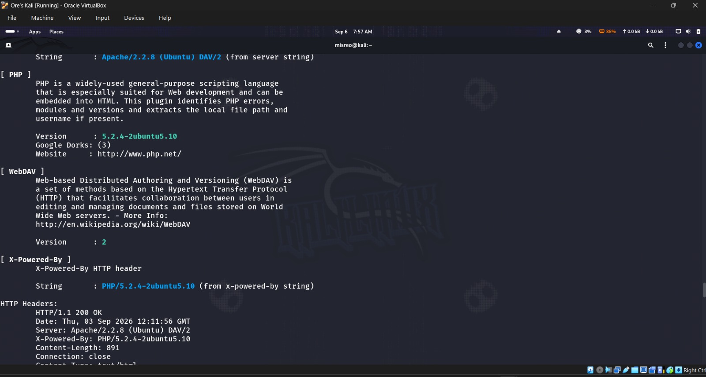
Figure 26. Verbose WhatWeb plugin details and HTTP headers.
Full plugin-level detail plus the raw HTTP headers.

Step 26: Aggression level 1
Level 1 kept things minimal and still returned the same core stack — Apache 2.2.8, Ubuntu, PHP 5.2.4, WebDAV 2, and the page title.

Step 27: Aggression level 3
Level 3 threw in more verbose plugin evidence, but didn't really change the core identification from level 1.
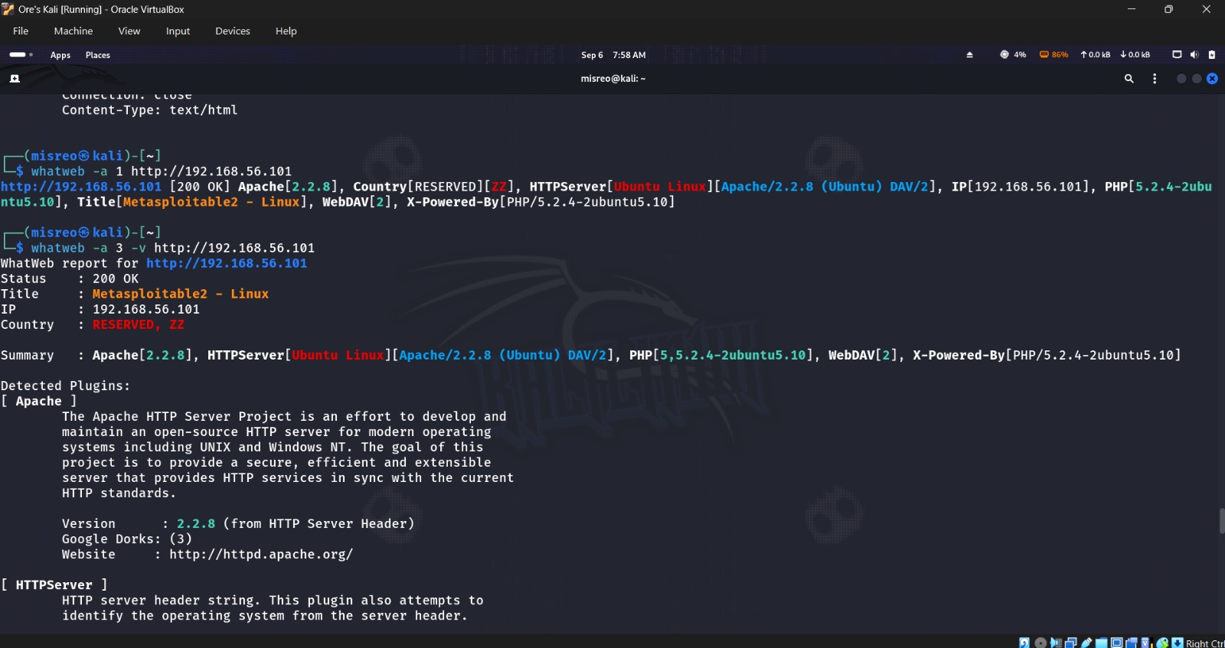
Figure 27. Comparison of WhatWeb aggression levels 1 and 3.
Levels 1 and 3 side by side — more detail, same underlying stack.
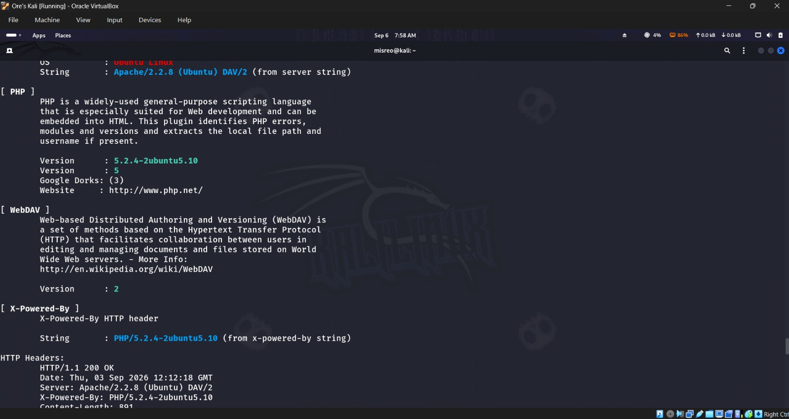
Figure 28. Continued level-3 plugin evidence and HTTP headers.
More of the level-3 plugin output and headers.

Step 28: Aggression level 4
Level 4 kept everything from before and additionally picked up Matomo — so the heaviest mode did find something new here, just at the cost of a lot more requests. Stayed inside the authorized lab for this one, as required.
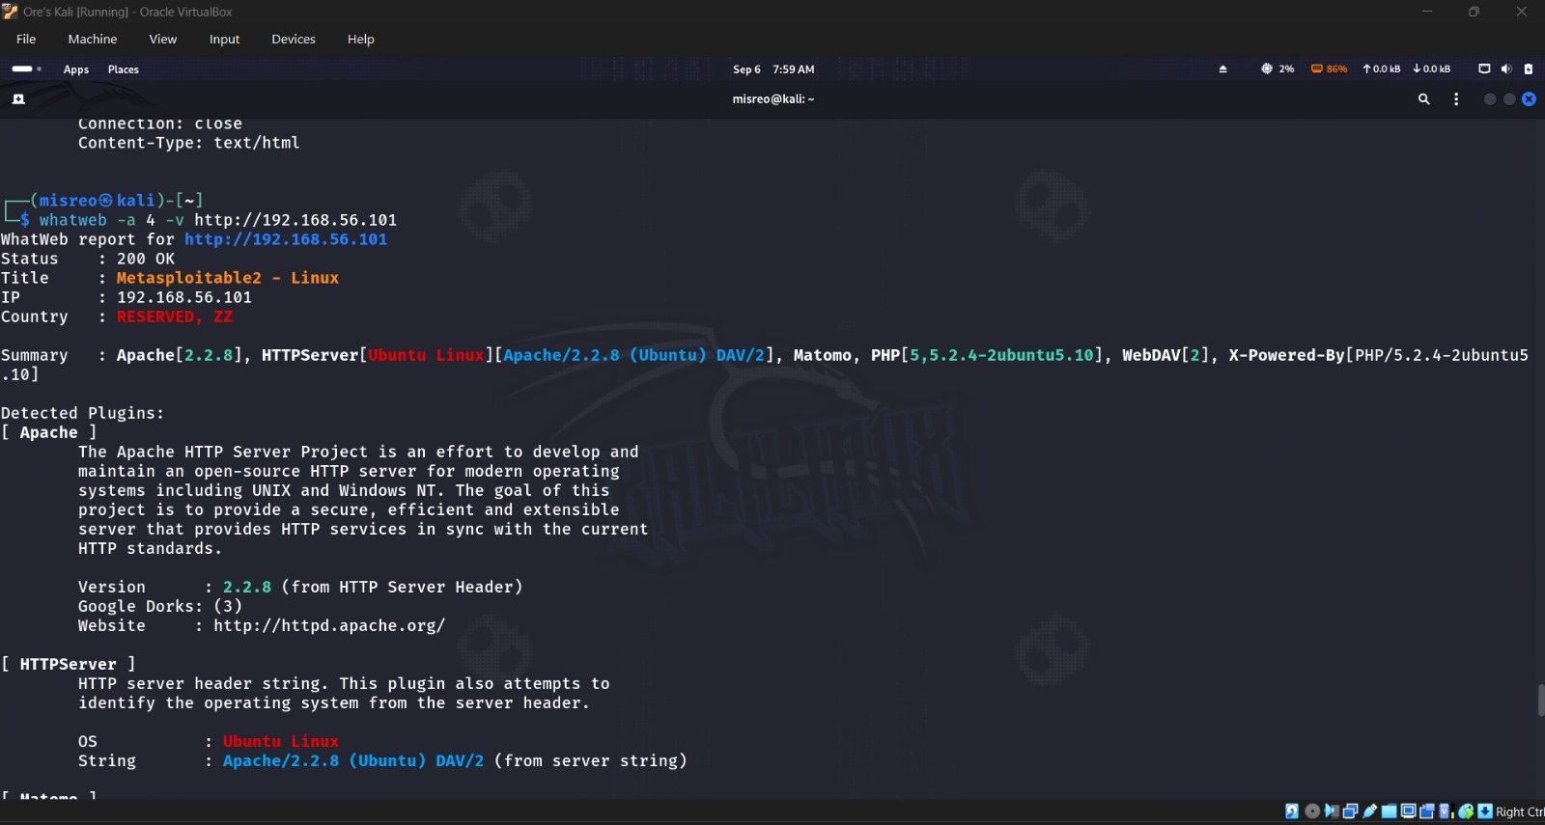
Figure 29. Level-4 WhatWeb output showing Matomo in addition to the core stack.
Level 4 catching the Matomo fingerprint alongside everything already known.
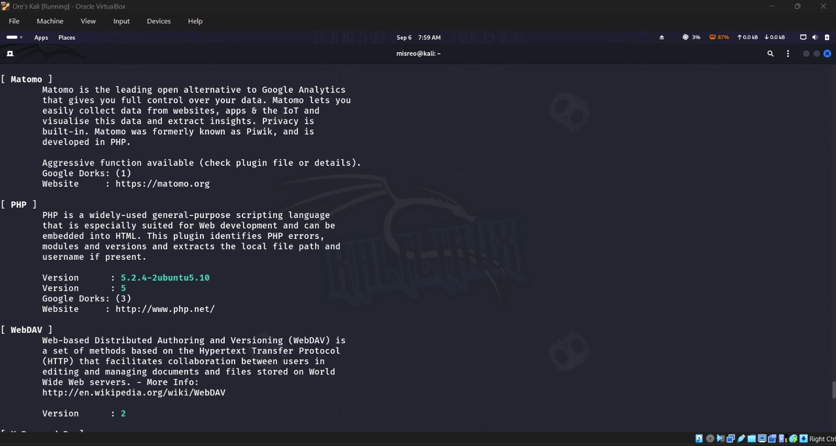
Figure 30. Continued level-4 Matomo, PHP, and WebDAV plugin evidence.
More of the level-4 plugin evidence for Matomo, PHP, and WebDAV.

Step 29: Follow redirects
Following redirects didn't actually change anything — the original URL still came back 200 OK with no redirect destination shown, so there's no redirect happening on this app.

Step 30: Save the WhatWeb result
Saved the verbose output to whatweb-results.txt and cat'd it back out to confirm it wrote properly — ls -l showed a 2,272-byte file sitting in /home/misreo.
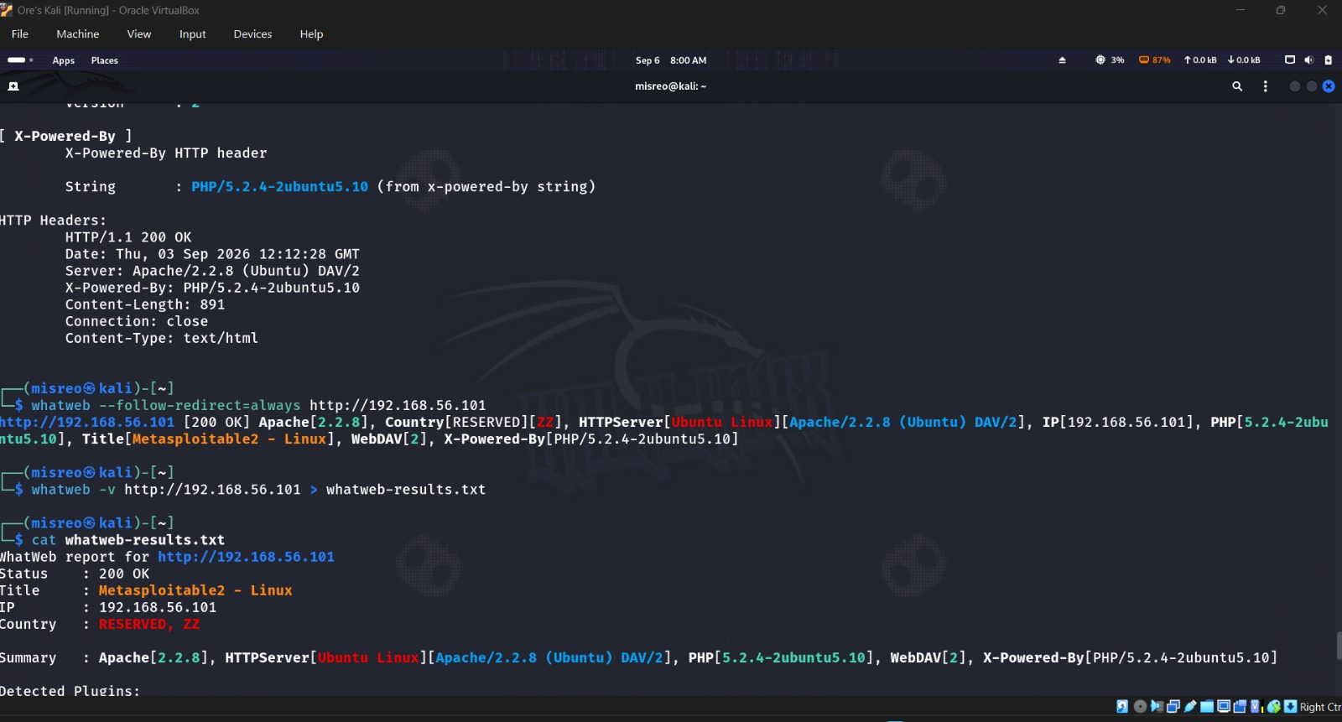
Figure 31. Redirect test, save command, and beginning of the saved WhatWeb output.
The redirect test, then the save command running and the file starting to print out.
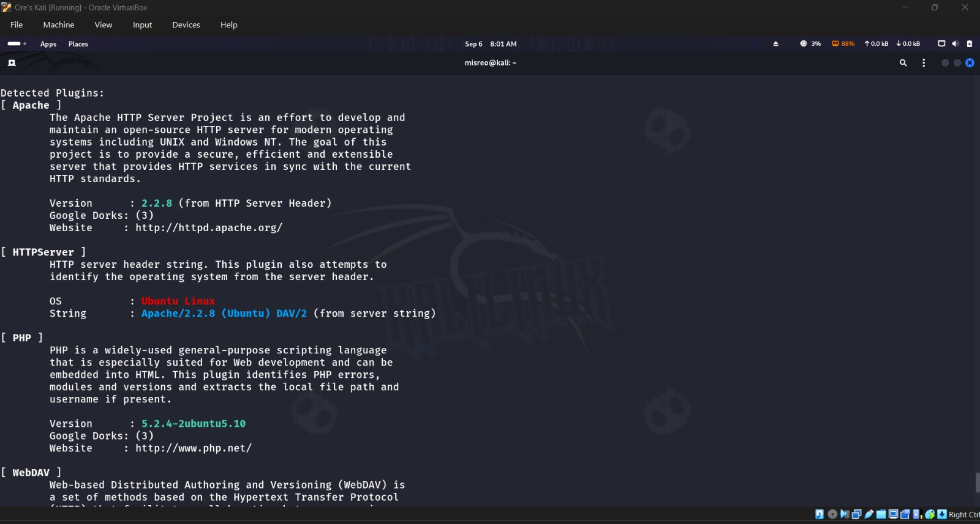
Figure 32. Saved WhatWeb plugin evidence displayed with cat.
The saved plugin evidence, read back with cat.
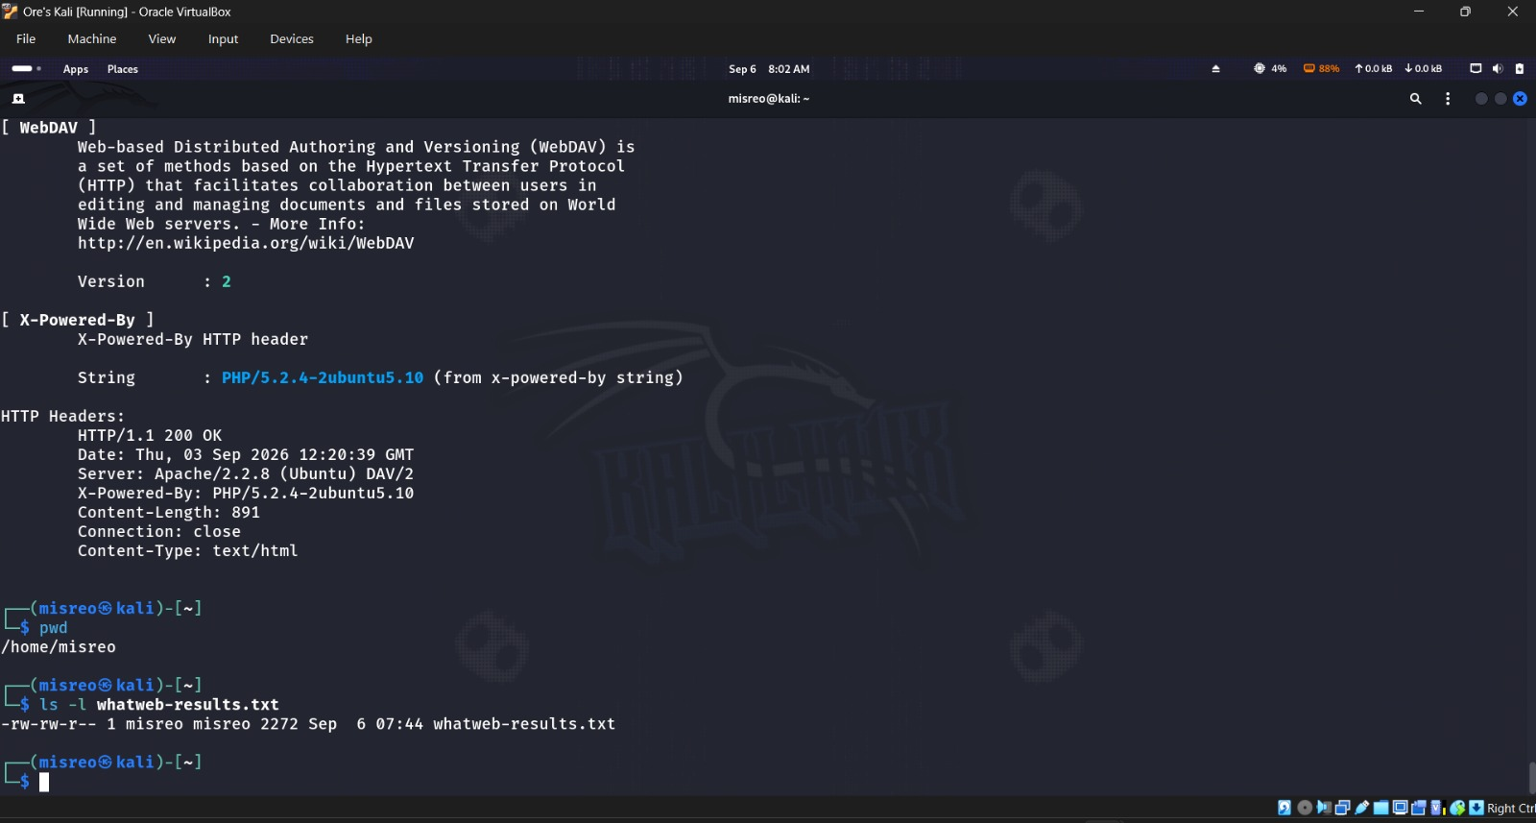
Figure 33. Final saved output, working directory, and file-existence confirmation.
The rest of the saved output, plus confirmation of the working directory and file size.

9. Scan Comparison Summary
Scan | Scope | Key result | Time
Default TCP | Common TCP ports | 23 open TCP ports | 0.28 s
Service/version | Common TCP ports + probes | Product/version details | 12.20 s
Version intensity 9 | Maximum version probes | No material change from normal -sV | 12.15 s
Aggressive | Versions, OS, NSE, traceroute | Expanded service and host context | 22.84 s
Full TCP | TCP 1–65535 | 30 open TCP ports; 7 additional | 5.87 s
Full TCP + versions | TCP 1–65535 + probes | Complete TCP service inventory | 134.66 s
Full TCP T4 | TCP 1–65535, faster timing | Same 30 open ports | 8.10 s
Selected ports | 7 specified TCP ports | All 7 open | 0.33 s
TCP 1–1024 | Continuous low-port range | Open services in range | 0.31 s
UDP | Common UDP ports | 4 open; 4 open|filtered | 1051.06 s
Top-20 UDP + versions | 20 common UDP ports + probes | DNS and NetBIOS detail | 111.45 s

WhatWeb mode | Request style | Findings
Basic | Default compact fingerprint | Apache, Ubuntu Linux, PHP, WebDAV, title, IP, HTTP 200
Verbose | Plugin-level description and headers | Expanded evidence for the same core technologies
Aggression 1 | Minimal requests | Same basic technology stack
Aggression 3 | Additional requests, verbose output | More detail; no material change to core ID
Aggression 4 | Heaviest mode used in this lab | Added Matomo fingerprint to the core stack
Follow redirects | Always follow redirect responses | No redirect observed; original URL returned 200 OK

10. Final Service Inventory
This pulls together every column the lab asked for. The TCP rows come from the full all-port service/version scan; the UDP rows combine the completed broad UDP scan with the top-20 version-specific one.
Port | Proto | State | Service | Version/Evidence | Command
21 | TCP | open | ftp | vsFTPd 2.3.4 | sudo nmap -p- -sV
22 | TCP | open | ssh | OpenSSH 4.7p1 Debian 8ubuntu1 (protocol 2.0) | sudo nmap -p- -sV
23 | TCP | open | telnet | Linux telnetd | sudo nmap -p- -sV
25 | TCP | open | smtp | Postfix smtpd | sudo nmap -p- -sV
53 | TCP | open | domain | ISC BIND 9.4.2 | sudo nmap -p- -sV
80 | TCP | open | http | Apache httpd 2.2.8 (Ubuntu) DAV/2 | sudo nmap -p- -sV
111 | TCP | open | rpcbind | v2 (RPC #100000) | sudo nmap -p- -sV
139 | TCP | open | netbios-ssn | Samba smbd 3.X–4.X; WORKGROUP | sudo nmap -p- -sV
445 | TCP | open | netbios-ssn | Samba smbd 3.0.20-Debian; WORKGROUP | nmap -sC -sV
512 | TCP | open | exec | netkit-rsh rexecd | sudo nmap -p- -sV
513 | TCP | open | login | OpenBSD or Solaris rlogind | sudo nmap -p- -sV
514 | TCP | open | shell | Netkit rshd | sudo nmap -p- -sV
1099 | TCP | open | java-rmi | GNU Classpath grmiregistry | sudo nmap -p- -sV
1524 | TCP | open | bindshell | Metasploitable root shell | sudo nmap -p- -sV
2049 | TCP | open | nfs | v2–4 (RPC #100003) | sudo nmap -p- -sV
2121 | TCP | open | ftp | ProFTPD 1.3.1 | sudo nmap -p- -sV
3306 | TCP | open | mysql | MySQL 5.0.51a-3ubuntu5 | sudo nmap -p- -sV
3632 | TCP | open | distccd | distccd v1; GNU 4.2.4 | sudo nmap -p- -sV
5432 | TCP | open | postgresql | PostgreSQL DB 8.3.0–8.3.7 | sudo nmap -p- -sV
5900 | TCP | open | vnc | VNC protocol 3.3 | sudo nmap -p- -sV
6000 | TCP | open | X11 | Access denied | sudo nmap -p- -sV
6667 | TCP | open | irc | UnrealIRCd | sudo nmap -p- -sV
6697 | TCP | open | ircs-u | UnrealIRCd | sudo nmap -p- -sV
8009 | TCP | open | ajp13 | Apache Jserv (Protocol v1.3) | sudo nmap -p- -sV
8180 | TCP | open | http | Apache Tomcat/Coyote JSP engine 1.1 | sudo nmap -p- -sV
8787 | TCP | open | msgsrvr | Ruby DRb RMI (Ruby 1.8) | sudo nmap -p- -sV
34437 | TCP | open | mountd | v1–3 (RPC #100005) | sudo nmap -p- -sV
42652 | TCP | open | status | v1 (RPC #100024) | sudo nmap -p- -sV
45372 | TCP | open | java-rmi | GNU Classpath grmiregistry | sudo nmap -p- -sV
58162 | TCP | open | nlockmgr | v1–4 (RPC #100021) | sudo nmap -p- -sV
53 | UDP | open | domain | ISC BIND 9.4.2 | sudo nmap -sU --top-ports 20 -sV
68 | UDP | open|filtered | dhcpc | No version returned | sudo nmap -sU
69 | UDP | open|filtered | tftp | No version returned | sudo nmap -sU
111 | UDP | open | rpcbind | Open in completed UDP scan | sudo nmap -sU
123 | UDP | open|filtered | ntp | No version returned | sudo nmap -sU --top-ports 20 -sV
135 | UDP | open|filtered | msrpc | No version returned | sudo nmap -sU --top-ports 20 -sV
137 | UDP | open | netbios-ns | NetBIOS name service; WORKGROUP | sudo nmap -sU --top-ports 20 -sV
138 | UDP | open|filtered | netbios-dgm | No version returned | sudo nmap -sU
520 | UDP | open|filtered | route | No version returned | sudo nmap -sU --top-ports 20 -sV
903 | UDP | open|filtered | ideafarm-panic | No version returned | sudo nmap -sU
1434 | UDP | open|filtered | ms-sql-m | No version returned | sudo nmap -sU --top-ports 20 -sV
2049 | UDP | open | nfs | Open in completed UDP scan | sudo nmap -sU
49152 | UDP | open|filtered | unknown | No version returned | sudo nmap -sU --top-ports 20 -sV

11. Observations and Analysis

Default versus full TCP scanning
23 ports on the default scan versus 30 on the full sweep — the extra seven (3632, 6697, 8787, 34437, 42652, 45372, 58162) show exactly why a default scan, while quick, can miss stuff sitting outside the common port list.

Normal versus maximum version intensity
Both runs landed on the same products and versions, and intensity 9 didn't really buy anything extra this time — similar runtime too.

Timing-template comparison
5.87s for the plain full scan versus 8.10s for T4 — T4's meant to be faster on solid networks, but a single run can still swing around depending on system load and response timing.

TCP versus UDP
TCP gave clean, fast open/closed answers. UDP was a completely different story — no handshake to lean on, so a lot of ports just sat there silent and came back open|filtered instead of a clear answer.

NSE value
NSE filled in a lot of the picture that port numbers alone couldn't — anonymous FTP, SSH key algorithms, SMBv1 support, HTTP metadata, RPC mappings, SMB host identity.

WhatWeb value
WhatWeb stayed focused on the web side specifically rather than the whole host — Apache, Ubuntu, PHP, WebDAV, the page title, headers — and level 4 was the one that turned up Matomo on top of all that.

12. Student Questions
1. What is reconnaissance?
Reconnaissance is just the controlled information-gathering step before any deeper testing happens. Here that meant finding the live host, its open ports, the services and versions running, OS clues, and whatever web tech was exposed.
2. What is the difference between host discovery and port scanning?
Host discovery is about finding which machines are even online in a network range. Port scanning goes further and checks one specific host to see which ports are open, closed, or filtered, and what's listening.
3. Explain open, closed, and filtered.
Open means something's actually accepting traffic. Closed means the host answered but nothing's listening. Filtered means Nmap genuinely can't tell either way because something's blocking or altering the probe.
4. What does -sV do?
-sV turns on service/version detection — Nmap sends protocol-specific probes to work out the actual product and version behind a port.
5. What does -O do?
-O turns on OS fingerprinting — Nmap compares how the target responds against its own fingerprint database and gives back an estimate, like the Linux 2.6.x result here.
6. What does -A combine, and why is it noisier?
-A bundles OS detection, version detection, the default NSE scripts, and traceroute into one scan. It's noisier simply because it's sending a much wider variety of probes than a plain port scan would.
7. What does -p- mean?
-p- tells Nmap to scan every TCP port from 1 to 65535, instead of sticking to the default common-port list.
8. Why can UDP scans take longer?
UDP doesn't have a handshake, so an open service might just not respond to a probe it doesn't recognize — and a filtered port can look the same. Nmap ends up waiting, retrying, and trying more specific probes before it can call it either way, which adds up.
9. What does -sC do?
-sC runs Nmap's default set of NSE scripts, which pull in generally useful info — banners, protocol details, page titles, host keys, that kind of thing.
10. What information did the HTTP title and headers scripts reveal?
The title script returned “Metasploitable2 - Linux” exactly. The headers script showed Apache/2.2.8 (Ubuntu) DAV/2, PHP/5.2.4-2ubuntu5.10, connection close, and text/html.
11. What did SMB, SSH, and FTP enumeration add?
SMB showed SMBv1 (NT LM 0.12) plus host details like the METASPLOITABLE NetBIOS name. SSH gave up its DSA and RSA host-key algorithms. FTP enumeration confirmed the vsFTPd 2.3.4 banner, and the default scripts also flagged that anonymous FTP login is allowed.
12. What is the difference between Nmap service detection and WhatWeb fingerprinting?
Nmap service detection looks across a whole bunch of ports and figures out what's listening on each one. WhatWeb only cares about the web side — it uses headers, page content, and plugins to fingerprint the actual web-app stack behind an HTTP endpoint.
13. How did WhatWeb levels 1, 3, and 4 differ?
Level 1 stuck to minimal requests and got the core stack. Level 3 added a lot more plugin detail without really changing the main identification. Level 4 was the heaviest and the only one that actually turned up something new — Matomo.
14. Why must aggressive scanning and fingerprinting remain inside the authorized lab?
Aggressive scans throw a lot more traffic at a target and can trip alerts, mess with fragile services, or just flat-out break the law if there's no permission behind it. Keeping it inside the authorized, isolated lab is what keeps this whole exercise both safe and legal.

13. Conclusion
By the end of this, I'd confirmed 192.168.56.101 as the authorized Metasploitable 2 target, reachable from Kali at 192.168.56.102. The default scan found 23 open TCP ports; the full sweep pushed that to 30. Service detection turned up a deliberately old pile of services — vsFTPd, OpenSSH, Apache, Samba, MySQL, PostgreSQL, VNC, IRC, Tomcat, RPC, and a couple of remote shell services. UDP added DNS, RPC, NetBIOS, and NFS into the mix, plus several open|filtered ports. Nmap's OS guess landed on Linux 2.6.x, NSE filled in a good amount of protocol/config detail, and WhatWeb confirmed the Apache/PHP/WebDAV stack — with its top aggression level being the one to catch Matomo. If there's one thing this exercise really drove home, it's that a solid service inventory needs more than one technique, and none of it means anything without staying inside an actually authorized scope.

Command Cheat Sheet
Host discovery: nmap -sn <network-range>
Default scan: nmap <target-ip>
Versions: nmap -sV <target-ip>
OS: sudo nmap -O <target-ip>
Aggressive: sudo nmap -A <target-ip>
All TCP: sudo nmap -p- <target-ip>
UDP: sudo nmap -sU <target-ip>
Default scripts: nmap -sC -sV <target-ip>
WhatWeb basic: whatweb http://<target-ip>
WhatWeb level 3: whatweb -a 3 -v http://<target-ip>
WhatWeb level 4: whatweb -a 4 -v http://<target-ip>

Appendix A: Command and Evidence Checklist
Step | Command/Task | Status | Evidence
1 | ip addr | Completed | Figure 2
2 | ifconfig | Completed | Figure 1
3 | ping -c 4 192.168.56.101 | Completed | Figure 2
4 | nmap -sn 192.168.56.0/24 | Completed | Figures 2–3
5 | nmap 192.168.56.101 | Completed | Figures 3–4
6 | nmap -sV 192.168.56.101 | Completed | Figures 4–5
7 | nmap -sV --version-intensity 9 ... | Completed | Figures 5–6
8 | sudo nmap -O ... | Completed | Figures 6–7
9 | sudo nmap -A ... | Completed | Figures 7–11
10 | sudo nmap -p- ... | Completed | Figures 11–12
11 | sudo nmap -p- -sV ... | Completed | Figures 12–13
12 | sudo nmap -p- -T4 ... | Completed | Figures 13–15
13 | nmap -p 21,22,23,25,80,139,445 ... | Completed | Figure 15
14 | nmap -p 1-1024 ... | Completed | Figures 15–16
15 | sudo nmap -sU ... | Completed | Figures 16–17
16 | sudo nmap -sU --top-ports 20 -sV ... | Completed | Figures 17–18
17 | nmap -sC -sV ... | Completed | Figures 18–21
18 | nmap -p 80 --script http-title ... | Completed | Figure 22
19 | nmap -p 80 --script http-headers ... | Completed | Figure 22
20 | nmap -p 139,445 --script smb-protocols ... | Completed | Figure 23
21 | nmap -p 22 --script ssh-hostkey ... | Completed | Figure 23
22 | nmap -p 21 -sV --script banner ... | Completed | Figure 24
23 | curl -I http://192.168.56.101 | Completed | Figure 24
24 | whatweb http://192.168.56.101 | Completed | Figure 25
25 | whatweb -v http://192.168.56.101 | Completed | Figures 25–26
26 | whatweb -a 1 ... | Completed | Figure 27
27 | whatweb -a 3 -v ... | Completed | Figures 27–28
28 | whatweb -a 4 -v ... | Completed | Figures 29–30
29 | whatweb --follow-redirect=always ... | Completed | Figure 31
30 | Save and display whatweb-results.txt | Completed | Figures 31–33

Appendix B: Completion Declaration
- Only the authorized Metasploitable 2 target was scanned.
- All required Nmap scan types were completed.
- Important Nmap options and states were interpreted.
- Safe NSE enumeration was completed.
- WhatWeb aggression levels were compared.
- A complete TCP/UDP service inventory was prepared with all required columns.
- All fourteen student questions were answered using the observed lab results.

